NOTTINGHAM UNIVERSITY HOSPITALS NHS TRUST

Documentation Control

**Dress Code and Uniform Policy**

|  |  |
| --- | --- |
| Reference | HR/P&C/008 |
| Open/Restricted | Open |
| Approving Body | Senior Management Team |
| High Risk Policy | No |
| Date Approved | 7 June 2024 |
| Implementation Date | 7 June 2024 |
| Version | Version 7 |
| Summary of Changes from Previous Version | * Lightweight uniform now available (with reference to Staff Perimenopause and Menopause Policy) * Greater emphasis on inclusive procedures and language * Updates to infection control procedures regarding jewellery * Policy brought in-line with NHS Uniform & Work wear guidance |
| Supersedes (Version & date) | Version 6 – October 2018 |
| Consultation Undertaken | HR Policy Sub Group  Nursing and Midwifery Board  Senior Management Team |
| Date of Completion of Equality Impact Assessment | November 2023 |
| Legal and/or Accreditation Implications | * Equality Act 2010 * Employment Relations Act (1999) * Rehabilitation of Offenders Act (1974) * Human Rights Act (1998) * Trade Union and Labour Relations (Consolidation) Act 1992 * Part Time Workers - Prevention of Less Favourable Treatment Regulations (2001) * Fixed Term Employees - Prevention of Less Favourable Treatment Regulations (2002) * Health & Safety At Work Act (1974) * Agency Worker Regulations (2010) |
| Target Audience | All managers, new and existing employees, Accredited Trade Union / Professional Organisations representatives |
| Review Date | 1 June 2027 |
| Lead Director | Chief Nurse |
| Author/Further guidance | Lorraine Hourd  Divisional Nurse – AMB Management |
| Key words to assist with searches for this policy | Personal protective equipment (PPE)  Hospital acquired infection (HAI)  Operating department attire  Issue & maintenance of uniforms  Shoes  Jewellery  Extreme Heat |
| Note to readers | Staff Perimenopause and Menopause Policy |

**Contents**

1. Introduction 4

2. Executive summary 4

3. Policy statement 4

4. Definitions 6

5. Roles and responsibilities 6

6. Policy and/or procedural requirements 6

7. Training and Implementation 15

8. Impact Assessments 16

9. Policy / Procedure Monitoring Matrix 17

10. Relevant legislation, national guidance and associated NUH documents: 18

11. Appendix 1 – Care Guidance for Office wear Garments 19

12. Appendix 2 – Care Guidance for Healthcare Garments 20

|  |
| --- |
| Introduction |

|  |  |
| --- | --- |
| 1.1  1.2  1.3 | The aim of this policy is to ensure that **all staff** (both directly and indirectly employed) whilst on duty within the Trust are dressed in such a way that maximises staff and patient safety. Nothing should be worn that could compromise patient or staff safety during care  Agency staff/work experience students and contractors are required to adhere to this Policy and this should be explained to prior to them attending work at NUH.  Employees and volunteers represent the Trust to our patients/visitors and the public. It is important that they can recognise staff and have confidence and trust in them. In order to achieve this and to ensure compliance with the Trust values and behaviours the highest standards of appearance are essential at all times.  This policy and guidance incorporate current Health and Safety, Infection Prevention and Control, and Department of Health (DoH) guidance on dress and uniform codes. |

|  |
| --- |
| Executive summary |

|  |  |
| --- | --- |
| 2.1 | Nottingham University Hospitals NHS Trust (NUH) aims to provide the highest standards of quality patient care. Adherence to the uniform policy is essential at all times to ensure the safety of our staff and patients. |

|  |
| --- |
| Policy statement |

|  |  |
| --- | --- |
| 3.1  3.2  3.3  3.4 | **All employees** must ensure that:   * Their overall appearance is smart, clean and safe. * Jewellery is discreet and will not put patients, themselves or other employees at risk.   The Dress Code and Uniform Policy, including the wearing of ‘theatre greens’ and, or any other protective clothing is mandatory for all staff.  A number of areas have specific departmental guidelines for uniform and will need to ensure staff are aware that these supplement this policy e.g. orthopaedic theatres, sterile services or pharmacy.  A Trust issued identification badge must be worn in a visible place while the staff member is on-site or representing the Trust off-site. This should be worn in such a way that is easily visible to both patients and staff  Personal protective equipment (PPE) consists of items of additional clothing e.g. gloves, shoes with protective toe-caps or anti-slip soles, aprons, white coats or other items worn on the person (e.g. respirators) which protect the wearer from a hazard.  Gloves and plastic aprons, used for clinical care, must not be worn outside clinical areas unless following infection control special precautions (e.g. transporting a patient who is MRSA positive), and must always be removed when exiting a clinical area (when hands should be washed).  The need for personal protective equipment is determined by departmental risk assessment, with the assistance of Health and Safety/Infection Prevention and Control teams if required.  Where the need for personal protective equipment has been recognised in the risk assessment, its use must be made compulsory by the manager and monitored. Details should be recorded in the Health and Safety Compliance Review.   Failure to follow a Trust Policy could result in disciplinary action being taken, up to and including dismissal. |

|  |
| --- |
| Definitions |

|  |  |
| --- | --- |
| 4.1 | GMC: General Medical Council  NMC: Nursing & Midwifery Council  Professional Crocs: ‘Croc’ type shoes with fully covered top/front of shoe and strap around heel. |

|  |
| --- |
| Roles and responsibilities |

|  |  |
| --- | --- |
| 5.1  5.2  5.3 | All line managersmust ensure staff are supplied with the appropriate uniform and that the uniform policy and dress code is adhered to, they must ensure training is provided if necessary and must monitor compliance. They must also ensure when requests for replacement uniforms are made that old uniforms are returned to the Linen Room in exchange for new ones. Uniforms must also be returned on leaving the Trust.  Staffwill wear and maintain their uniforms in accordance with the uniform policy.  Management Action -Where dress is not in accordance with this policy it is legitimate to ask staff to rectify this immediately. If it requires staff to return home to change, the time off duty will be unpaid. Repeated disregard of this policy will be considered in line with the Trust’s Disciplinary Policy/Procedures. |

|  |
| --- |
| Policy and/or procedural requirements |

|  |  |
| --- | --- |
| 6.1  6.1.1  6.1.2  6.1.3  6.2  6.3  6.3.1  6.3.2  6.4  6.4.1  6.4.2  6.4.3  6.5  6.5.1  6.5.2  6.5.3  6.5.4  6.5.5  6.5.6  6.5.7  6.5.8  6.5.9  6.5.10  6.5.11  6.5.12 | Dress Code and Uniform Policy for ALL staff  The following are general requirements relating to ALL staff:   * Clothing must be practical, clean, safe, smart and in good state of repair. * It is important to attend work in clean odour free clothes; this includes not smelling of smoke. Clothes should be changed regularly and if wearing a uniform it must be changed daily. * Jewellery, whilst acknowledging that piercings are seen as a form of individual expression, it is important that staff do not lose sight of that piercings can be a source of hospital acquired infection (HAI) via cross-transmission of bacteria from earlobe holes to fingers. All piercings (e.g. nose, ears) should be small studs only. Please see below for additional guidance for clinical staff. * Hair must be worn off the collar when staff are in any clinical area. * Beards and moustaches should be neatly trimmed * Clothing must allow for full range of movement and must not hinder staff during moving and handling procedures. * Tattoos which include offensive language or any images/wording relating to violence and/or aggression must be covered. It is acknowledged that some religions/cultures use henna to decorate their bodies at certain times and this is acceptable. * Footwear must be clean and smart and not put the wearer at risk of injury. Flip flops or very casual shoes/sandals are not permitted. For staff working within clinical areas, high heels should not be worn. Departmental risk assessments will indicate where and which staff are required to wear specific footwear. * Lanyards used for displaying ID badges must have a pull release catch on them. Any decoration should be health related. Lanyards must not be worn when involved in direct patient care. They should also be removed when off duty and off site. * Patient facing staff should not wear very casual trousers/jeans/leggings e.g. ripped jeans, denim etc. are not permitted. * Any garments showing the abdomen/lower back or allowing underwear to be visible are not permitted. * Strapless or cleavage revealing tops are not permitted. * Skirts or dresses mid thigh (very short) are not permitted. * Uniforms must be covered when travelling to and from work if using public transport   Wearing of a full veil/niqab  It is important that patients are able to communicate freely with each professional providing healthcare. In some situations this may require the professional to set aside personal and cultural preferences in order to provide effective care.  An example is that a patient may find that a face veil (as in a niqab) worn by the healthcare professional may present an obstacle to effective communication, if this is the case the face veil should be removed whilst the communication takes place.  The Trust considers this is in line with the views of professional regulatory bodies (notably GMC and NMC).  For staff working in theatres then wearing of any head wear/veils would need to be reviewed and risk assessed on an individual basis  Transgender & non –binary/gender non-conforming/gender fluid staff  Transgender is a broad term which describes people who feel their gender identity (the gender with which they identify) does not match the gender they were assigned at birth.  Many will undergo the process of aligning their life and physical identity to match their gender identity, and this is called transitioning.  Transgender employees must be able to express their identity within the organisation’s dress code in a way which includes being able to access appropriate uniform options that reflect their identity.  The staff member will be given the option to be supplied with a selection of uniform types which suits them including provision for non-binary/gender non-conforming /gender fluid staff where more than one style of uniform maybe required.  Code and Uniform Policy for staff working in the clinical (patient) areaThe following key principles relate to all staff working in the clinical area whether in uniform or wearing own clothes. This is also relevant to our staff working outside of the Trust premises i.e. in the Community.   * Small plain stud earrings may be worn. * One plain wedding ring / commitment ring / civil partnership ring (no stones) may be worn. All other jewellery, including watches and necklaces must not be worn. * Bangles worn for religious reasons, that are not normally removed, must be assessed and approved to be worn by the infection prevention and control team prior to being worn in a clinical area * Discreet natural looking makeup can be worn; false adhesive eyelashes which may easily fall off are not permitted. Natural looking false eyelash extensions which are not at risk of falling off are permitted. * Nails must be kept short and not be longer than fingertip. False nails, nail gel, nail art/jewels and varnish must not be worn. * No sleeves below the elbow to be worn when in clinical areas. In exceptional circumstances where disclosure of forearms causes concerns on religious grounds advice should be sought by the manager from the Infection Prevention and Control Team. * Neck ties can be worn but must be tucked into the shirt; bow ties may also be worn. * Plain black, navy or brown shoes of a cleanable material with covered toe and heel areas, anti-slip, quiet soles and heels no higher than 2.5cm (1 inch) must be worn. * Trainers, if black or navy and ergonomically suitable, may be worn. * Professional clogs are only worn in theatres. If in the clinical area, but not in uniform, shoes must have soft soles and closed over foot/toe. * Hair must be clean, off the face and tied back off the collar (long pony tails are not acceptable for reasons of health and safety) with a plain clip/band when in clinical environment. * Care must be taken when placing hard objects such as pens or attaching sharp objects such as badges and fob watches to breast pockets of uniform to ensure they do not cause harm to patients when delivering care. * Scissors must not be placed in breast pockets and if they are required to be carried on person then they should be placed in a hip pocket. * Tape i.e. Micro pore should not been worn dangling from lanyards * Nursing and midwifery staff who choose to wear a belt with a buckle as part of their uniform must ensure this is removed before delivering any aspect of patient care * Black or neutral tights/stockings must be worn with uniform dresses. Socks must be plain navy or black under navy trousers. * Plain cardigan or service/specialty sweatshirt/hoody, of a colour appropriate to the professional group/specialty/division may be worn but not when staff are in a clinical environment * Outdoor wear is provided dependent on the role and must be worn as appropriate. * Theatre greens should not be removed from theatre areas unless clinically necessary. * When in uniform (even outside of the clinical areas) staff must abide by the rules for working in a clinical environment under Section 6.2   Uniform to support perimenopause and Menopausal symptoms  Employees who wear a uniform or PPE may request to adjust their uniform/remove layers where possible in response to symptoms and may be given access to shower or washing facilities and be allowed to change their uniform if the need arises during the working day. This may be agreed as a means of supporting an employee to manage their symptoms and must be discussed with their line manager and agreed in advance on an individual basis, taking into account individual needs and clinical requirements.  The provision of additional uniformsmay be considered to ensure individuals can change during the day. Pro Natural fibres like cotton are preferable to synthetic materials if an employee is experiencing hot flushes and/or sweating so cotton scrubs may be worn in these instances with the prior agreement of the manager in line with the above.  If uniform adjustments are not possible, due consideration should be given to moving an employee to another role whilst the symptoms remain. As with all adjustments, this should be regularly reviewed.  Where there is a proposal to introduce new or modified uniform, the needs of staff undergoing hormonal or menopausal symptoms should be considered  Uniform in extreme heat conditions  In extreme heat conditions a risk assessment ([HSE Thermal Comfort Checklist](https://www.hse.gov.uk/temperature/assets/docs/thermal-comfort-checklist.pdf)) must be completed by the chief nurse/deputy chief nurse, with actions taken as appropriate. For example, tailored smart navy or black shorts maybe worn and/or tights maybe removed.  Operating department attire  This protocol sets out the correct wearing of operating department attire within and outside the operating department. The protocol was designed with the following factors in mind:   * The need to protect staff against contamination from blood and body fluids and the risks of cross infection and cross contamination. * The need to promote a clean environment. * The need to promote a professional image.   Standard peri-operating department/birthing areas attire   * Clean attire as issued by the Trust must always be worn in a clinical area. Any item of operating department clothing must be changed as soon as possible when contaminated with blood or body fluids. * All jewellery must be removed prior to entering the operating department (except for those items mentioned in 6.2.2) * All hand jewellery, wrist watches and fitness trackers must be removed prior to scrubbing. * Operating department footwear - clogs, wellington boots or other appropriate footwear as determined by risk assessment to ensure protection against penetrative injury. * A single use fluid repellent mask must be worn correctly by:   + All scrubbed team members   + By non-scrubbed members of the team if deemed necessary following a risk assessment of exposure to blood and/or body fluids.   + Surgical face masks should be worn when performing invasive spinal procedures such as myelography, lumbar puncture and spinal anesthesia. * Dispose of the mask, handling ties only, directly into an appropriate waste bin after each patient. Masks must be removed prior to leaving the operating theatre. * A disposable head covering must be worn covering all hair. * Washable fabric hats may only be worn after agreement with the infection prevention and control team. * A full mask covering beards etc. must be worn. * Eye protection, spectacles/ goggles, visors must be worn if there is a risk of splashing or spraying of blood or body fluids and when reconstituting a chemical solution.   Standard operating department attire outside of an operating department area, but within the clinical area (CICU / AICU / HDU / ED or Ward):   * Clean operating department attire, including hat, without mask. * Operating department footwear may be worn provided it is clean.   Attire when outside operating department areas and outside  clinical areas.   * Items of operating department attire (including foot wear) should not be worn when visiting non- clinical areas including the dining room, shops, outside the main building, out on the street and any other area that is considered to be outside an area where patient care / treatment occurs. Staff must not travel into work wearing operating department clothing. * When clinical reasons dictate that operating department attire has to be worn outside a clinical area, every item must be changed before entering an operating theatre. The only exception to this would be personnel responding to an emergency call.   Issue and Maintenance of Uniform  The majority of clinical staff will be issued with three uniforms as standard, however, additional uniforms can be requested as required.  Uniforms must be changed every day.  When washing uniforms, individuals must ensure they are washed at the hottest temperature for the fabric.  This can have personal tax implications for further information contact the link below.  [Claim tax relief for your job expenses: Overview - GOV.UK (www.gov.uk)](https://www.gov.uk/tax-relief-for-employees)  Uniforms soiled with blood/body fluids must be changed immediately, Scrubs can be provided if necessary. Appropriate soluble wash bags are provided in clinical areas to transport garments home.  Uniforms must be maintained in good condition. The trust do not carry out repairs therefore if unable to repair the garment a replacement uniform will be provided.  Veils / Turbans / Skull caps (including a Kippah or Yarmulke), should be treated the same as uniform items with regards to laundering    Uniforms damaged by the wearer, e.g. not following care instructions, making alterations, will be replaced at the wearer’s own cost. Care instruction guidelines are attached to this policy (Appendix 2).  It is the individual’s responsibility to return uniforms to their manager when employment with the Trust ceases and no later than 7 working days after leaving the Trust. Failure to do so will result in a charge to the individual/deduction from final salary being made. The manager will be responsible for returning uniforms to Linen Services.  Where uniforms have not been returned, the manager will need to inform Linen Services and request costings so that they (the manager) can send appropriate costings to Pay Services in order for the relevant charge/deduction to be made to the individual. Information on charges can be obtained from Linen Services Management.  Requests to wear uniform outside Trust premises for formal occasions or where promoting the Trust must be authorised by the Matron/Department Manager as appropriate  For those staff who wear a uniform and become pregnant, maternity uniforms can be requested from their line manager |

|  |
| --- |
| Training and Implementation |

|  |  |  |
| --- | --- | --- |
| 7.1 | | Training  Managers need to ensure that all staff are aware of the requirements and adhere to the policy. |
| 7.2 | Implementation  7.2.1 All line managers must ensure this policy is cascaded to their current staff and monitor implementation and compliance  7.2.2 All new staff and volunteers must receive the policy. This should include employees of the Trust and employees of other organisations who work at the Trust. Agency staff, work experience placements and contractors must also be made aware of and adhere to the Policy   * + 1. The policy will be reviewed every 3 years | |
| 7.3 | Resources  No additional resources are required. | |

|  |
| --- |
| Impact Assessments |

|  |  |
| --- | --- |
| 8.1 | Equality Impact Assessment  An equality impact assessment has been undertaken on this draft and has not indicated that any additional considerations are necessary. |
| 8.2 | Values and Behaviours |

The Trust’s TEAM NUH Values and Behaviours describe the principles and beliefs of our people and show that ‘we listen, we care’. The TEAM NUH Values and Behaviours have been considered in relation to this policy.

|  |
| --- |
| Policy / Procedure Monitoring Matrix |

|  |  |  |  |  |  |  |
| --- | --- | --- | --- | --- | --- | --- |
| **Minimum**  **requirement**  **to be monitored** | **Responsible**  **individual/**  **group/**  **committee** | **Process**  **for monitoring**  **e.g. audit** | **Frequency**  **of monitoring** | **Responsible**  **individual/**  **group/**  **committee for review of**  **results** | **Responsible**  **individual/**  **group/**  **committee**  **for development**  **of action plan** | **Responsible**  **individual/**  **group/**  **committee**  **for monitoring**  **of action plan** |
| Adhere to dress code and uniform standards | All Managers |  | Ongoing | Human Resources and Staff Side | Human Resources Partnership Committee | Partnership Committee |
|  | Partnership Committee if any issues | Any issues raised | Monthly | Partnership Committee |  |  |

|  |
| --- |
| Relevant legislation, national guidance and associated NUH documents: |

|  |  |
| --- | --- |
| 10.1  10.2  10.3 | Legislation   * Equality Act 2010 * Employment Relations Act (1999) * Rehabilitation of Offenders Act (1974) * Human Rights Act (1998) * Trade Union and Labour Relations (Consolidation) Act 1992   Regulations   * Part Time Workers - Prevention of Less Favourable Treatment Regulations (2001) * Fixed Term Employees - Prevention of Less Favourable Treatment Regulations (2002) * Health & Safety At Work Act (1974) * Agency Worker Regulations (2010)   Guidance   * Dress codes and sex discrimination – what you need to know May 2018 Government Equalities Office * Research Paper * Dress codes and appearance at work: Body supplements, body modification and aesthetic labour (2016) Research by ACAS * Behaviours and rituals in the operating theatre: A report from the hospital infection society working party on infection control in operating theatres. Journal of Hospital Infection (2002) 51:241-255 * NHS National Services Scotland. Standard infection control precautions literature review – Surgical Face Masks. 2016 * NHS Uniforms and Work wear: Guidance for NHS employers |

# Appendix 1 – Care Guidance for Office wear Garments

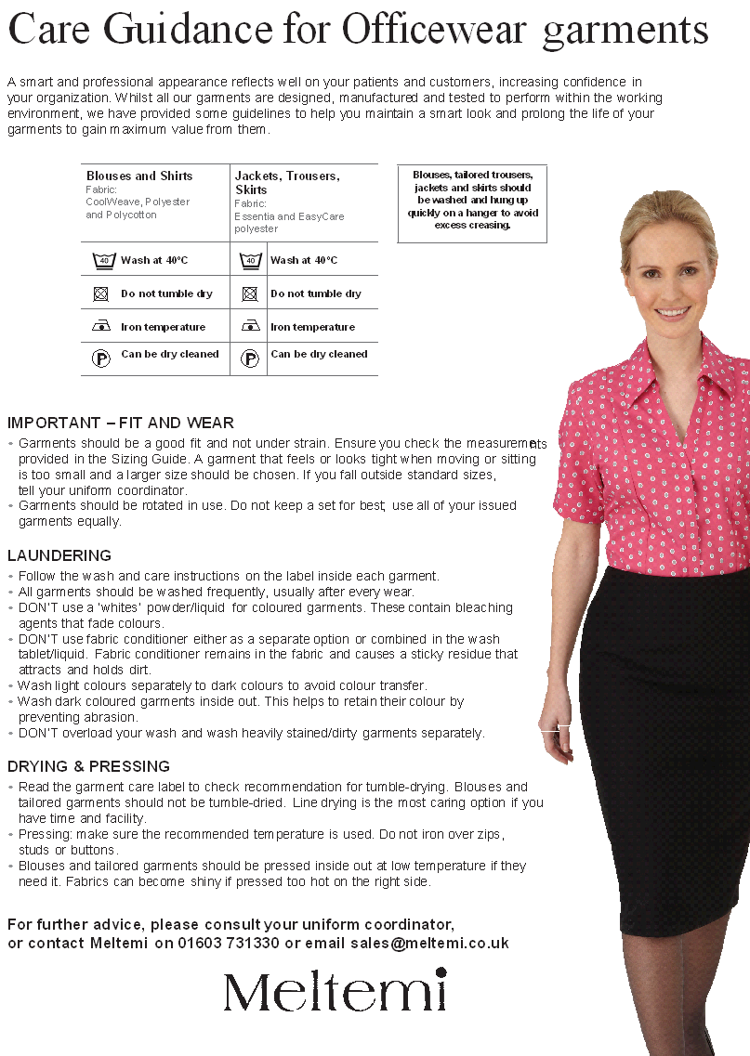

# Appendix 2 – Care Guidance for Healthcare Garments

